WEEK 3 INTERNSHIP REPORT
Comprehensive Data Analysis Reporting and Presentation
Spotify Most Streamed Songs 2025 Dataset

Intern | Bala Gayatri
Internship | YuvaIntern – NSDC
Week | Week 4
Technology | R / RStudio (Posit Cloud)
Dataset | Most Streamed Spotify Songs 2025

- Executive Summary
This final report integrates the data analysis work completed across the first three weeks of the YuvaIntern internship under NSDC using the Most Streamed Spotify Songs 2025 dataset. The project progressed through a complete analytical workflow: data cleaning and preprocessing, exploratory visualization and insight communication, and statistical analysis with predictive modeling. During Week 1, the dataset was inspected for missing values and duplicate records, a sparsely populated ranking variable was removed, potential outliers were examined, numerical streaming variables were standardized, and selected categorical variables were encoded. Week 2 transformed the prepared information into visual evidence using R, ggplot2, base R plotting, and corrplot. Visualizations were used to communicate song popularity, artist representation, streaming distributions, collaboration patterns, and relationships between streaming variables. Week 3 extended the project into formal statistical analysis and predictive modeling. Pearson correlation testing, normality testing, an 80:20 train-test split, multiple linear regression, MAE, RMSE, R-squared, five-fold cross-validation, and regression diagnostics were used to assess the predictive relationship between selected streaming measures and total Spotify streams. Week 4 consolidates these stages into a cohesive report that emphasizes methodology, results, interpretation, limitations, business implications, and future analytical directions.
2.Table of Contents
1. Executive Summary
2. Context
3. Screenshot Checklist
4. Introduction
5. Objectives
6. Dataset Overview
7. Methodology
8. Integrated Analysis and Results
9. Discussion and Business Implications
10. Model Strengths, Limitations and Improvements
11. Challenges Overcome
12. Lessons Learned
13. Recommendations and Future Directions
14. R Code Appendix
15. Conclusion

3.ScreenShot Checklist

No. | Evidence / Screenshot | Report Section
1 | Cleaned dataset structure and summary | Data Preparation
2 | Missing-value verification | Data Preparation
3 | Top 10 Most Streamed Songs | Visualization Results
4 | Top 10 Artists by Number of Songs | Visualization Results
5 | Daily Streams histogram | Visualization Results
6 | Solo vs Collaboration chart | Visualization Results
7 | Daily Streams vs Total Streams scatter plot | Visualization Results
8 | Pearson correlation test | Statistical Analysis Results
9 | Correlation heatmap | Statistical Analysis Results
10 | Regression model summary | Predictive Modeling Results
11 | MAE, RMSE and R-squared | Predictive Modeling Results
12 | Five-fold cross-validation output | Predictive Modeling Results
13 | Regression diagnostic plots | Model Diagnostics
14 | Actual vs Predicted plot | Predictive Modeling Results

4. Introduction
Data-driven decision making requires more than collecting information. Raw data must first be prepared, then explored and communicated visually, and finally examined using statistical and predictive techniques. This project applies that complete process to a publicly available Spotify 2025 streaming dataset. Music-streaming data provides a useful analytical setting because popularity is highly variable, numerical streaming measures can be compared statistically, and categorical information such as artists and collaboration status can be used to explain patterns. The project was completed in R using Posit Cloud, with tidyverse and ggplot2 supporting data manipulation and visualization, corrplot supporting correlation analysis, and caret supporting data partitioning and cross-validation.

5. Objectives
Integrate the data-cleaning, visualization, statistical-analysis, and predictive-modeling work completed during Weeks 1-3.
Present the analytical workflow in a clear sequence from raw data preparation to model evaluation.
Communicate important streaming patterns using appropriate graphical visualizations.
Assess statistical relationships and significance using correlation and hypothesis testing.
Evaluate a multiple linear regression model using test-set metrics, cross-validation, and diagnostic analysis.
Discuss the practical meaning, limitations, challenges, and possible future extensions of the analysis.

6. Dataset Overview
The project uses the Most Streamed Spotify Songs 2025 dataset, containing 730 observations in the original analysis. The data includes song and artist information together with numerical streaming measures such as total Spotify streams, daily streams, and daily stream share percentage. A high-missingness field, wrapped_global_top10_rank, was removed during Week 1. The retained variables provided a combination of categorical and numerical information suitable for cleaning, visualization, statistical testing, and regression modeling.

Variable | Type | Analytical Role
track | Categorical | Song-level identification and ranking
artist | Categorical | Artist representation and aggregation
spotify_streams_total | Numerical | Primary streaming outcome / regression target
daily_streams | Numerical | Streaming activity and model predictor
daily_stream_share_pct | Numerical | Relative daily activity and model predictor
is_collaboration | Categorical/Binary | Solo-versus-collaboration comparison

7. Methodology
The methodology follows the chronological structure of the internship. Week 1 established data quality and preprocessing; Week 2 focused on visual exploration and communication; Week 3 applied inferential statistics and predictive modeling. Week 4 integrates the outputs from these stages and evaluates their combined analytical meaning.
7.1 Data Preparation and Cleaning
The original dataset was inspected using head(), str(), summary(), dim(), and names(). Missing values and duplicate records were checked. The wrapped_global_top10_rank field was removed because it contained extensive missingness. Potential outliers in total and daily streams were inspected using boxplots and were not automatically deleted because unusually high streaming values can represent genuine popularity rather than data errors. Key numerical streaming variables were standardized using scale(), while selected categorical variables were converted to numeric codes for preprocessing.
spotify <- read.csv("most_streamed_spotify_2025.csv")
spotify <- spotify %>% select(-wrapped_global_top10_rank)
colSums(is.na(spotify))
sum(duplicated(spotify))
spotify$spotify_streams_total <- scale(spotify$spotify_streams_total)
spotify$daily_streams <- scale(spotify$daily_streams)
spotify$daily_stream_share_pct <- scale(spotify$daily_stream_share_pct)
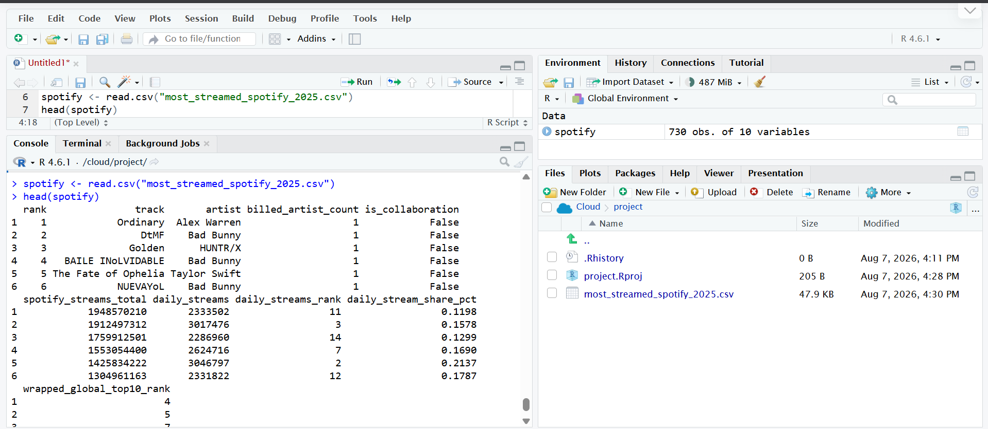
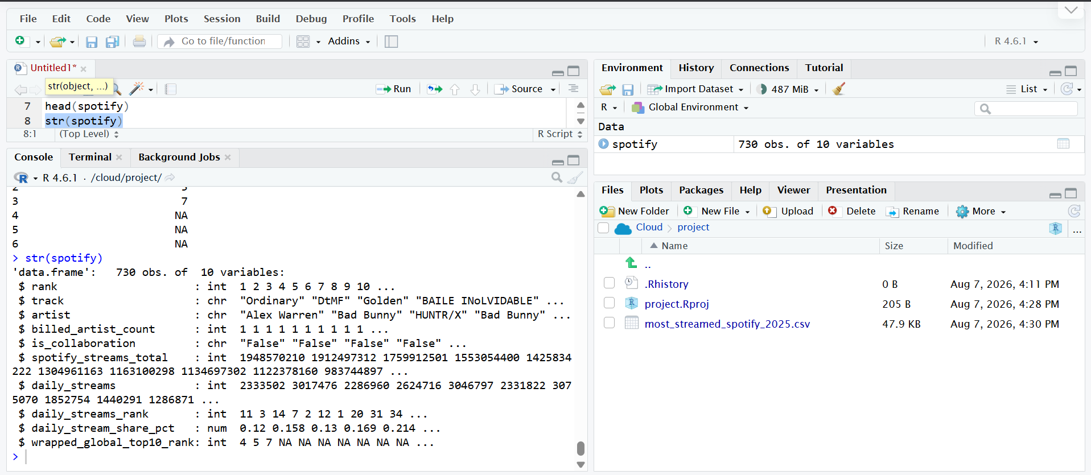
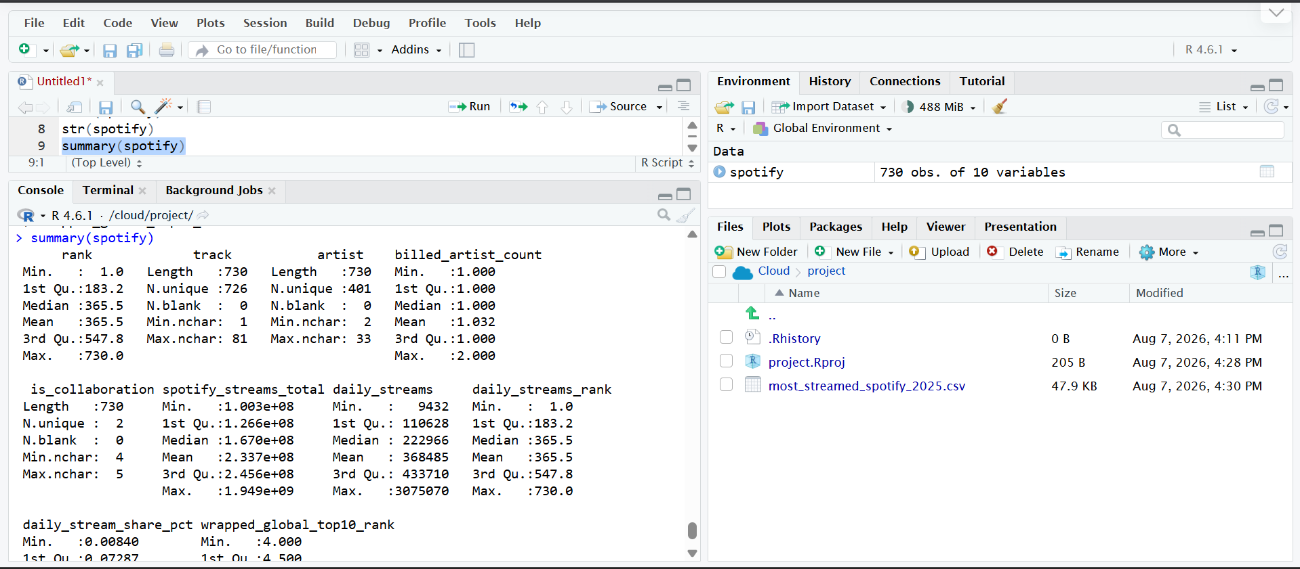
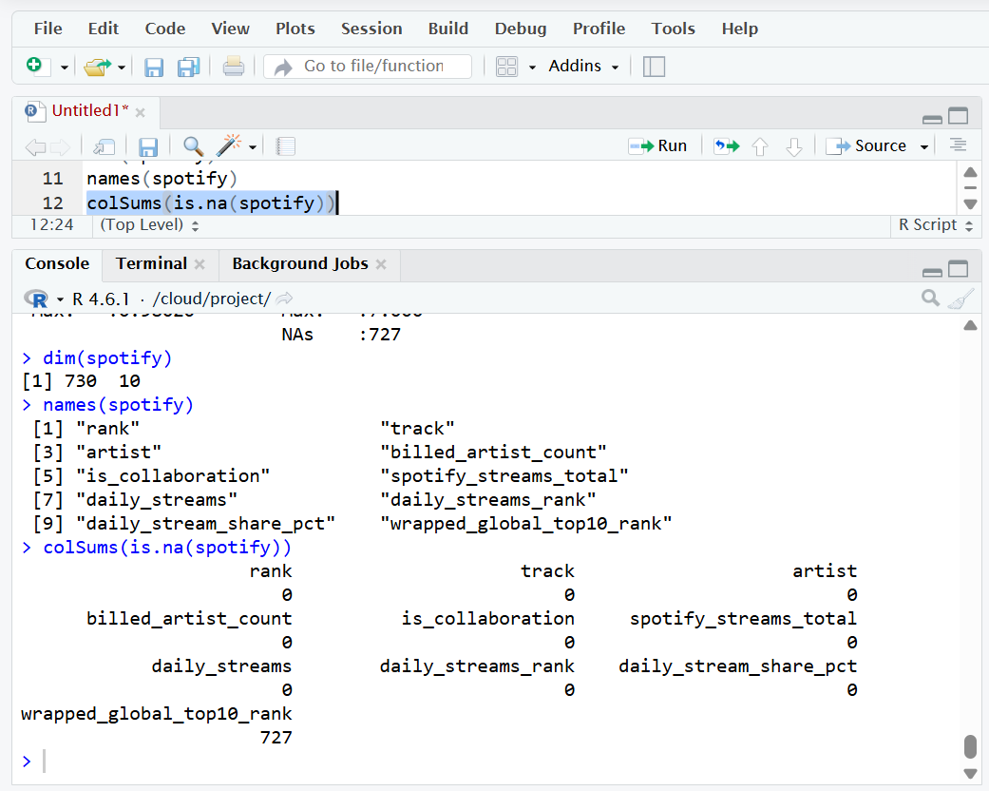

7.2 Exploratory Data Analysis and Visualization
Visualization was used to convert the dataset into interpretable evidence. Ranked bar charts were selected for song and artist comparisons, a histogram was used for the distribution of daily streams, a categorical bar chart was used for collaboration status, and a scatter plot was used to examine the relationship between daily and accumulated streams. These chart choices were based on the analytical question rather than visual variety alone.
7.3 Statistical Analysis
Pearson correlation analysis was used to quantify the relationship between daily streams and total Spotify streams. A Pearson correlation hypothesis test was then used to assess whether the relationship was statistically significant. Shapiro-Wilk testing was performed during Week 3 to examine normality characteristics. A correlation heatmap was also used to provide a broader view of relationships among numerical variables.
cor_test <- cor.test(
spotify$daily_streams,
spotify$spotify_streams_total,
method = "pearson"
)
cor_test
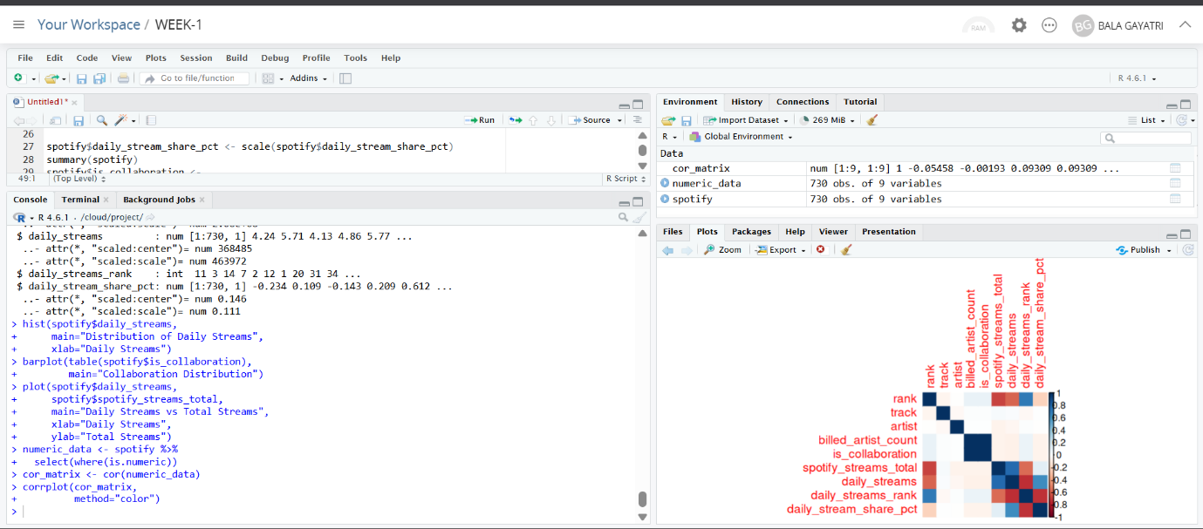

7.4 Predictive Modeling
A multiple linear regression model was used to predict spotify_streams_total from daily_streams and daily_stream_share_pct. The prepared dataset was divided into 80% training and 20% testing data using createDataPartition(). Model performance was assessed on the held-out test data using MAE, RMSE, and R-squared. Five-fold cross-validation was then applied to examine the stability of the model, followed by standard regression diagnostic plots and an actual-versus-predicted comparison.
set.seed(123)
train_index <- createDataPartition(
spotify$spotify_streams_total,
p = 0.80,
list = FALSE
)
train_data <- spotify[train_index, ]
test_data <- spotify[-train_index, ]
model <- lm(
spotify_streams_total ~ daily_streams + daily_stream_share_pct,
data = train_data
)
summary(model)
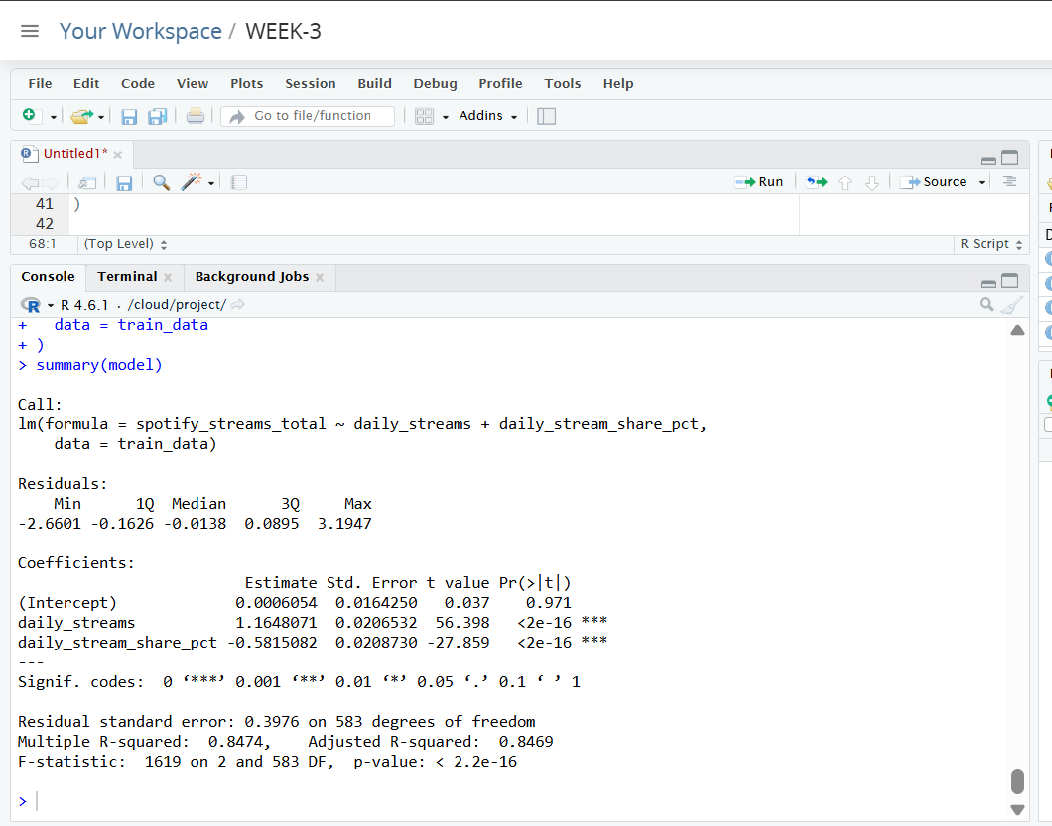

8. Integrated Analysis and Results
8.1 Data Cleaning Results
The Week 1 cleaning process produced a structured working dataset suitable for subsequent analysis. The major high-missingness ranking field was removed, duplicate and remaining missing-value checks were documented, and numerical streaming variables were standardized. Outlier inspection showed the presence of extreme streaming observations; these were retained because the context of the dataset makes unusually popular songs analytically meaningful.
8.2 Visualization Results
The visual analysis highlighted concentration in song and artist performance. The Week 2 analysis identified Ordinary by Alex Warren as the highest-streamed song in the dataset with 1,948,570,210 streams. Bad Bunny appeared most frequently among represented artists with 15 songs, followed by Sabrina Carpenter with 14 and Taylor Swift with 12. The collaboration analysis contained 707 non-collaboration songs and 23 collaboration songs, showing that collaborations represented a relatively small portion of the dataset. The scatter plot of daily streams against total streams visually reinforced the positive association between current streaming activity and accumulated popularity.
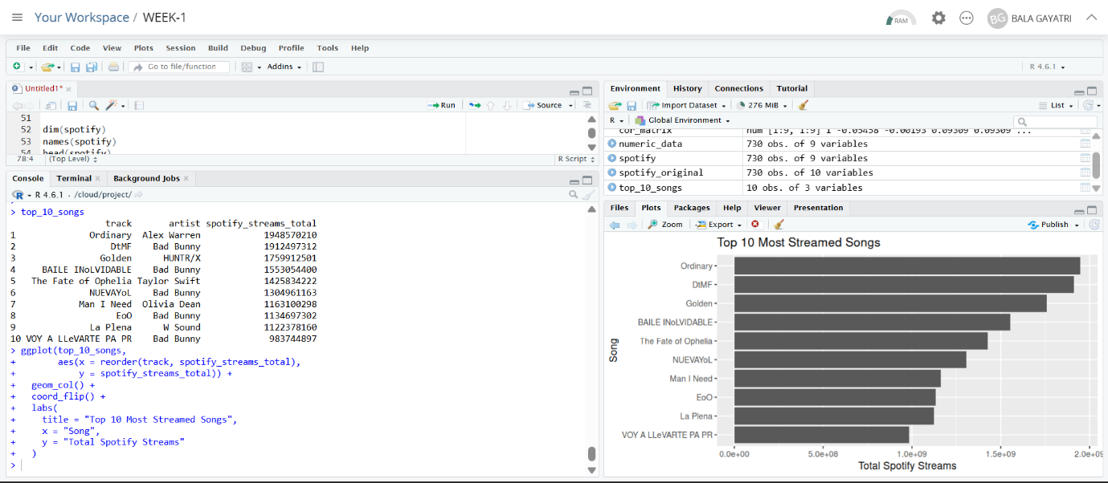
Top 10 Most Streamed Songs
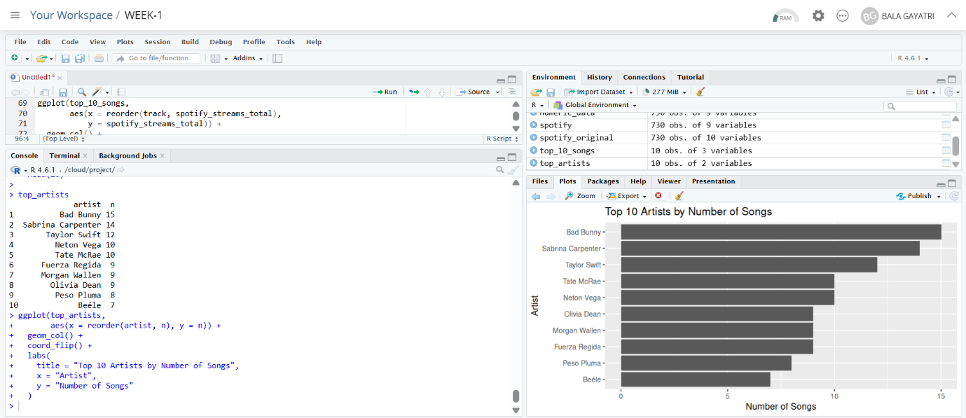
Top 10 Artists by Number of Songs
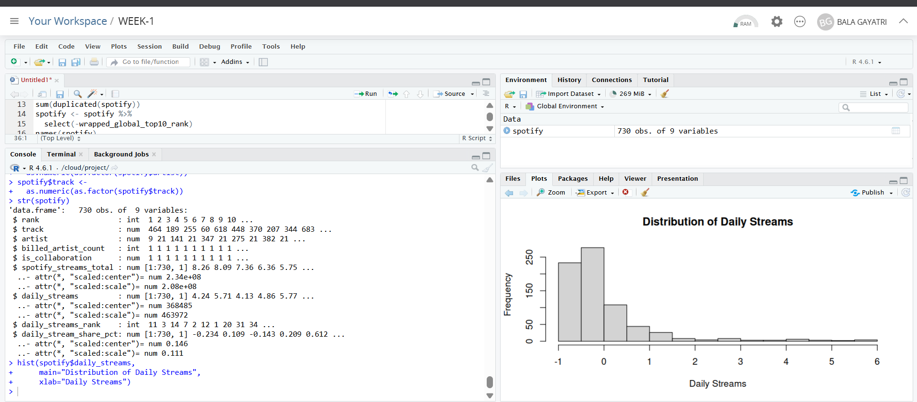
Distribution of Daily Streams
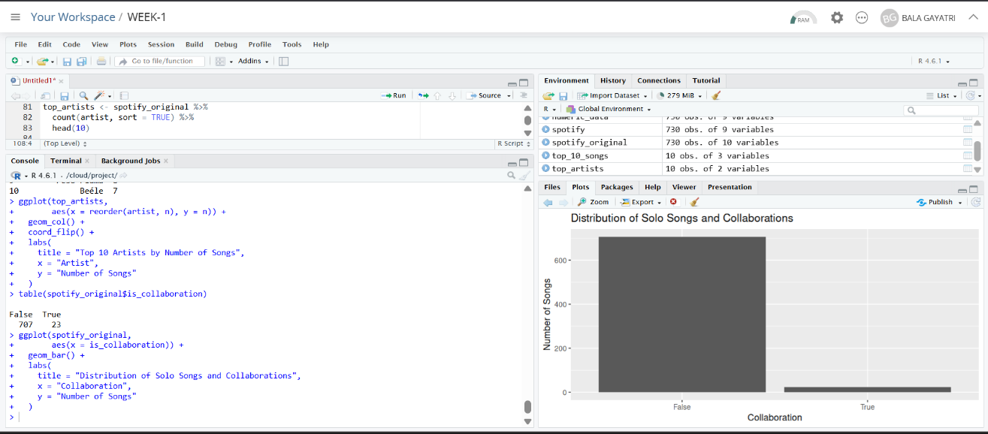
Solo Songs vs Collaborations
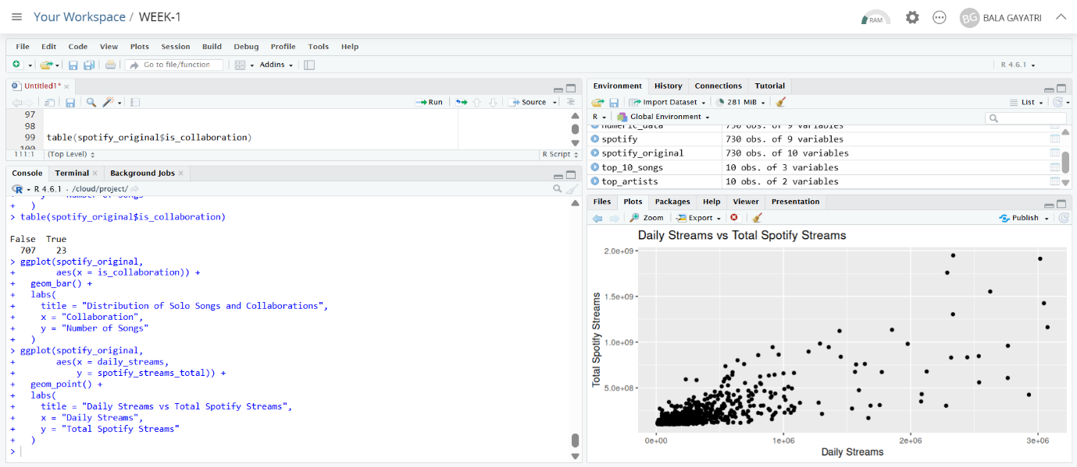
Daily Streams vs Total Spotify Streams

8.3 Statistical Analysis Results
The preliminary analysis obtained a correlation coefficient of 0.7795761 between daily streams and total Spotify streams, indicating a strong positive linear association in the dataset. The Week 3 Pearson correlation test provides the formal significance assessment for this relationship. Insert the exact p-value from your Posit Cloud output in the final version rather than estimating it. The normality-test results should likewise be reported using the exact Shapiro-Wilk statistics and p-values obtained during Week 3.
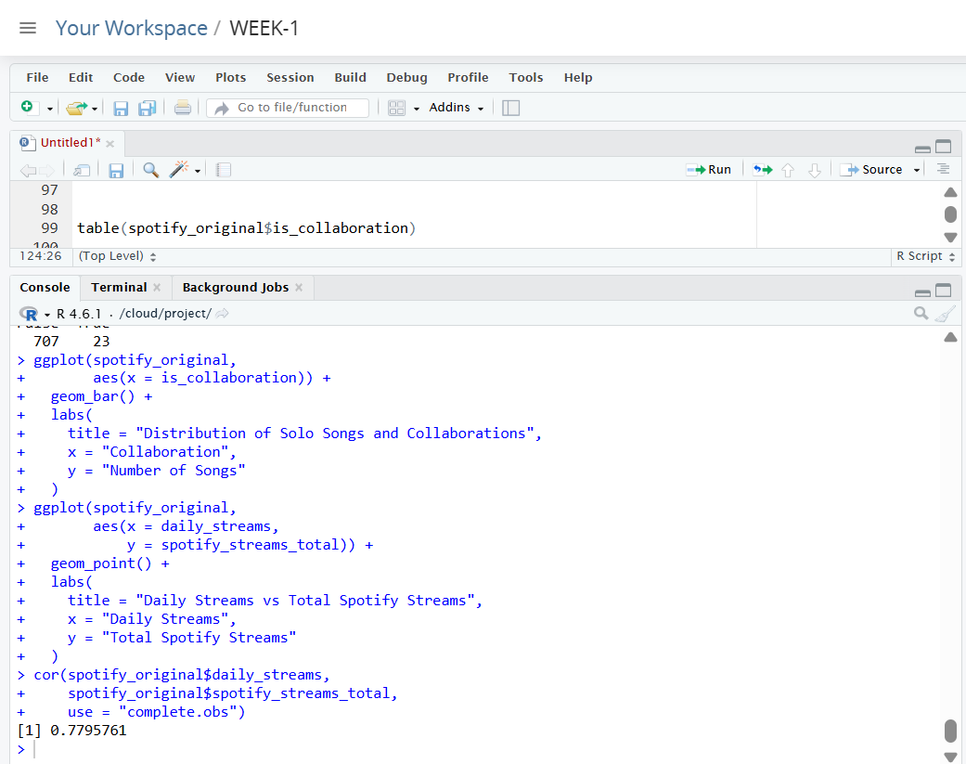
Pearson correlation test and exact p-value

Correlation heatmap

8.4 Predictive Modeling Results
The multiple linear regression model used daily_streams and daily_stream_share_pct to predict spotify_streams_total. The model was trained on approximately 80% of the prepared observations and evaluated on the remaining 20%. Performance was assessed using MAE, RMSE, and R-squared, while five-fold cross-validation provided an additional measure of generalization stability. The final report should insert the exact numerical values produced in Posit Cloud for these metrics and the model summary; no values should be assumed or fabricated.

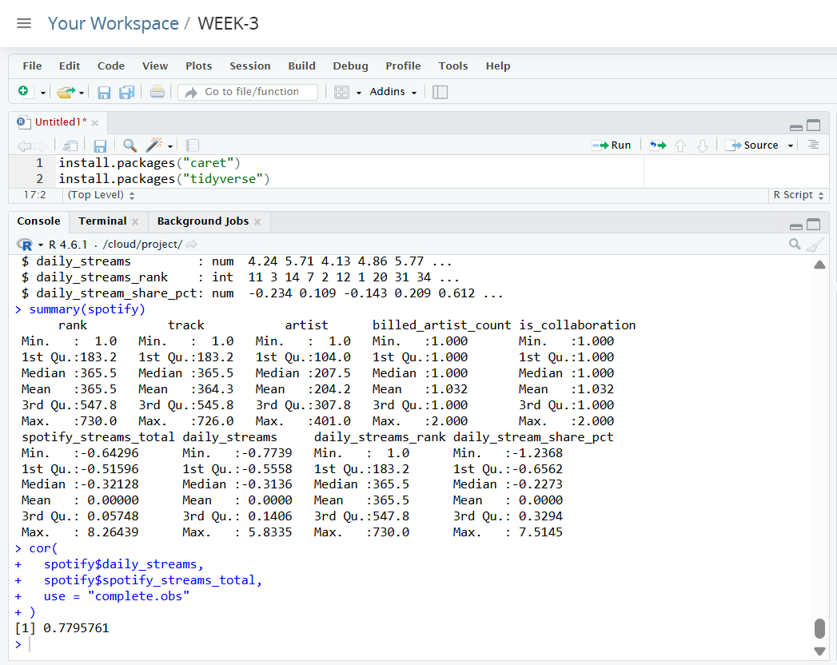
Regression model summary
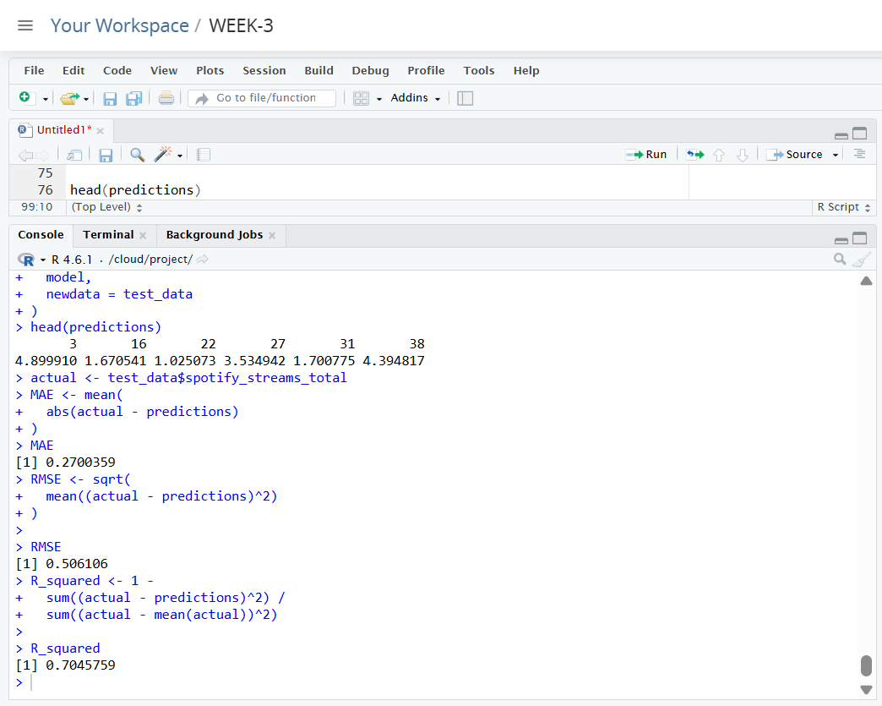
MAE, RMSE and R-squared
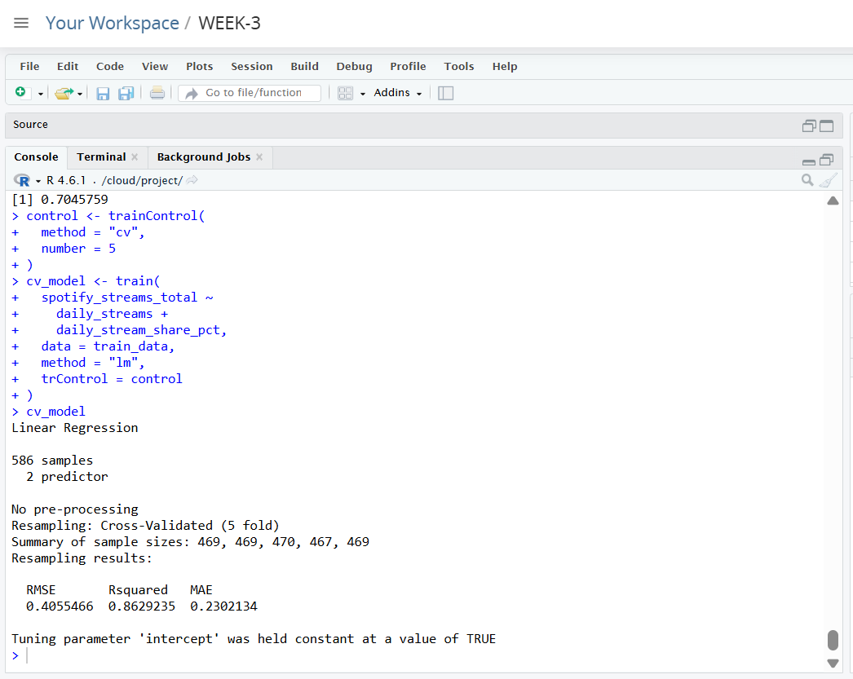
Five-fold cross-validation

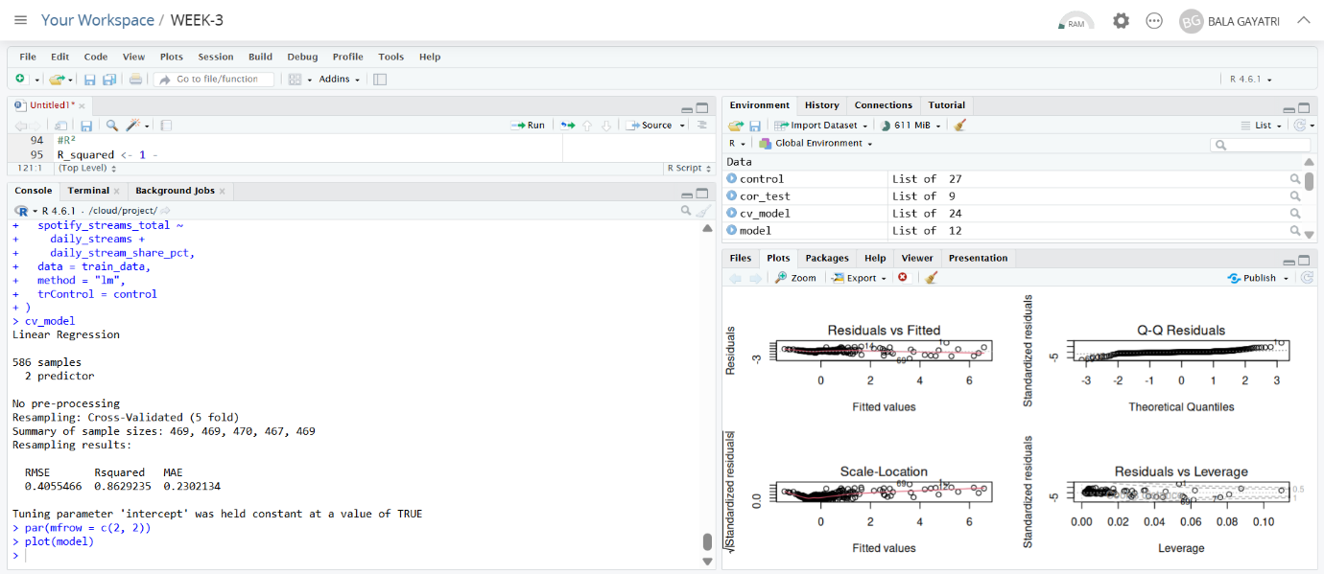
Regression diagnostic plots
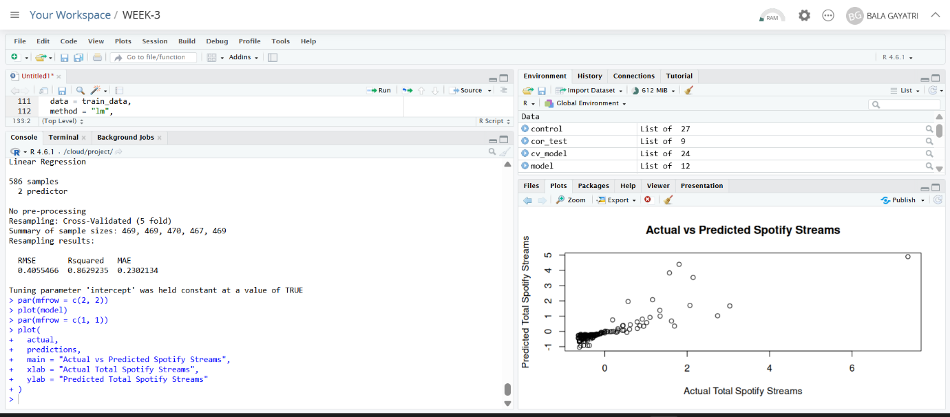
Actual vs Predicted Spotify Streams

9. Discussion and Business Implications
The combined analysis shows how different analytical stages answer different questions. Data cleaning establishes reliability, visualization reveals patterns, statistical testing evaluates whether relationships are supported quantitatively, and predictive modeling evaluates whether selected variables can estimate an outcome on unseen data. In a streaming context, the strong association between daily activity and accumulated streams suggests that current engagement can provide useful information about overall popularity. Artist-level and song-level rankings can help identify concentration of audience attention, while collaboration analysis describes the composition of the popular-song sample. These findings could support monitoring and prioritization decisions for music analytics, playlist strategy, campaign evaluation, or artist-performance tracking. However, the dataset alone does not establish causal effects; high daily streams may be associated with total popularity without proving why a song becomes successful.
10. Model Strengths, Limitations and Improvements
The regression workflow has several strengths: it uses a held-out testing set, reports multiple error metrics, applies five-fold cross-validation, and includes diagnostic analysis. At the same time, the model uses only two predictors and assumes a linear relationship. Streaming behavior can be influenced by many factors not represented in the model, including release timing, playlist placement, promotion, artist popularity, regional trends, and external events. Future versions could compare transformed regression models with tree-based or other non-linear methods, engineer additional features, evaluate multicollinearity, and use richer metadata. Model selection should be based on validated performance and interpretability rather than complexity alone.
11. Challenges Overcome
Preparing a dataset containing a high-missingness ranking field while avoiding unjustified imputation.
Distinguishing genuine high-streaming observations from potential data-quality outliers.
Maintaining separate original and preprocessed representations so that visualizations retain meaningful stream counts while modeling follows the Week 1 preprocessing workflow.
Selecting chart types that communicate the analytical question clearly to a non-technical audience.
Moving from descriptive correlation to formal hypothesis testing and predictive evaluation.
Evaluating a model using both a holdout test set and five-fold cross-validation rather than relying only on training performance.
12. Lessons Learned
The four-week project demonstrates that effective data analysis is an iterative process. Cleaning decisions affect every later stage, visualizations can reveal patterns that summary statistics alone may hide, and statistical significance does not automatically imply practical or causal importance. Predictive models must also be evaluated on unseen data and checked diagnostically rather than judged only by a fitted R-squared value. A further lesson is the importance of communicating results in language that connects technical outputs to understandable conclusions. Reproducible R code, output evidence, clear figures, and cautious interpretation together make an analysis more credible and useful.

13. Recommendations and Future Directions
Add richer song-level features such as release timing, genre, playlist exposure, and artist popularity if available.
Compare the current linear regression with alternative predictive algorithms and select models using cross-validated performance.
Investigate transformations for strongly skewed streaming variables and reassess model assumptions.
Explore artist-level and time-based trends where reliable temporal information is available.
Develop an interactive dashboard to allow non-technical users to explore song, artist, and streaming patterns.
Validate future models on newer or external Spotify data to assess whether relationships generalize beyond the current dataset.

14. R - Appendix
# Load packages
library(tidyverse)
library(corrplot)
library(caret)
# Load original and Week 1 cleaned datasets
spotify_original <- read.csv("most_streamed_spotify_2025.csv")
spotify <- read.csv("spotify_cleaned.csv")
# Data preparation evidence
dim(spotify)
str(spotify)
summary(spotify)
colSums(is.na(spotify))
# Top songs
top_10_songs <- spotify_original %>%
arrange(desc(spotify_streams_total)) %>%
select(track, artist, spotify_streams_total) %>%
head(10)
ggplot(top_10_songs,
aes(x = reorder(track, spotify_streams_total),
y = spotify_streams_total)) +
geom_col() + coord_flip() +
labs(title = "Top 10 Most Streamed Songs",
x = "Song", y = "Total Spotify Streams")
# Top artists
top_artists <- spotify_original %>%
count(artist, sort = TRUE) %>%
head(10)
ggplot(top_artists,
aes(x = reorder(artist, n), y = n)) +
geom_col() + coord_flip() +
labs(title = "Top 10 Artists by Number of Songs",
x = "Artist", y = "Number of Songs")
# Distribution and collaboration
hist(spotify_original$daily_streams,
main = "Distribution of Daily Streams",
xlab = "Daily Streams")
ggplot(spotify_original, aes(x = is_collaboration)) +
geom_bar() +
labs(title = "Solo Songs vs Collaborations",
x = "Collaboration", y = "Number of Songs")
# Daily vs total streams
ggplot(spotify_original,
aes(x = daily_streams, y = spotify_streams_total)) +
geom_point() +
labs(title = "Daily Streams vs Total Spotify Streams",
x = "Daily Streams", y = "Total Spotify Streams")
# Statistical analysis
cor_test <- cor.test(
spotify$daily_streams,
spotify$spotify_streams_total,
method = "pearson"
)
cor_test
numeric_data <- spotify %>% select(where(is.numeric))
cor_matrix <- cor(numeric_data, use = "complete.obs")
corrplot(cor_matrix, method = "color")
# Train-test split and regression
set.seed(123)
train_index <- createDataPartition(
spotify$spotify_streams_total,
p = 0.80,
list = FALSE
)
train_data <- spotify[train_index, ]
test_data <- spotify[-train_index, ]
model <- lm(
spotify_streams_total ~ daily_streams + daily_stream_share_pct,
data = train_data
)
summary(model)
# Predictions and metrics
predictions <- predict(model, newdata = test_data)
actual <- test_data$spotify_streams_total
MAE <- mean(abs(actual - predictions))
RMSE <- sqrt(mean((actual - predictions)^2))
R_squared <- 1 -
sum((actual - predictions)^2) /
sum((actual - mean(actual))^2)
MAE
RMSE
R_squared
# Five-fold cross-validation
control <- trainControl(method = "cv", number = 5)
cv_model <- train(
spotify_streams_total ~ daily_streams + daily_stream_share_pct,
data = train_data,
method = "lm",
trControl = control
)
cv_model
# Diagnostics
par(mfrow = c(2, 2))
plot(model)
par(mfrow = c(1, 1))
# Actual vs predicted
plot(actual, predictions,
main = "Actual vs Predicted Spotify Streams",
xlab = "Actual Spotify Streams",
ylab = "Predicted Spotify Streams")
abline(a = 0, b = 1)

15. Conclusion
This comprehensive report integrates the full analytical workflow completed across the internship. Week 1 established data quality through cleaning and preprocessing, Week 2 translated the data into meaningful visualizations, and Week 3 applied statistical testing and predictive modeling. The combined analysis identified a strong positive relationship between daily streams and total Spotify streams and demonstrated how a multiple linear regression model can be evaluated using test-set metrics, cross-validation, diagnostic plots, and actual-versus-predicted comparisons. More importantly, the project illustrates the value of a structured data-driven approach: reliable preparation supports trustworthy analysis, appropriate visualization improves communication, statistical methods strengthen evidence, and model evaluation prevents unsupported predictive claims. Future work can expand the feature set, compare additional modeling techniques, and validate findings on broader or newer streaming data.

